# Lab Manual 13

# Registers

## Objectives:

To familiarize with registers

## Register

The ideas in combinational circuits and sequential methods, when brought together as one system gives sequential building blocks, usually in the form or registers and counters. A register is a set of flip-flops with combinational logic to implement state transitions that allow information to be stored and retrieved from them. In the simplest form, a flip-flop is a one-bit register.

### D-Type Flip-Flop

This device 7474 contains two independent positive-edge-triggered D-type flip-flops with complementary outputs. The information on the D input is accepted by the flip-flops on the positive going edge of the clock pulse. LOW logic level on the preset or clear inputs will set or reset the outputs regardless of the logic levels of the other inputs.

|  |  |
| --- | --- |
| C:\Users\fast\Desktop\74ls74.png |  |

## Problems / Assignments

**Note: Don’t use clock generator in both circuits**

|  |  |
| --- | --- |
| **Problem 1** |  |

Implement a Four bit register with parallel load. Also implement the load control using clock gating in the same circuit.

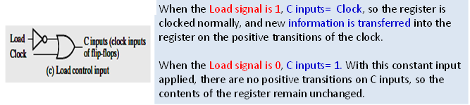

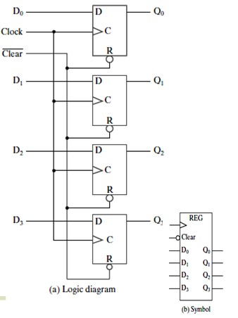

|  |  |
| --- | --- |
| **Problem 2** |  |

Implement a register that allows contents to be shifted in and out serially. Connect binary probe on each D-Flip Flop output

